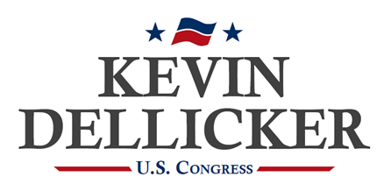
FOR IMMEDIATE RELEASE
March 22, 2024
Contact: Samuel Chen
schen@theliddellgroup.com
(484) 891-0345

FORMER STATE LEGISLATORS ENDORSE
KEVIN DELLICKER FOR CONGRESS

State Representatives Kelly Lewis and Justin Simmons back Kevin Dellicker.

LEHIGH VALLEY, PA – Two former members of the Pennsylvania House of Representatives announced their support of Kevin Dellicker’s campaign for Congress.

“I have known Kevin Dellicker for over 20 years and am proud to endorse him to represent us in Congress,” said Representative Kelly Lewis. “Kevin’s done extraordinary things in his business career and, at the same time, Kevin has humbly served our country for nearly three decades.”

Representative Justin Simmons also offered his endorsement of Dellicker: “It is with great pride that I lend my endorsement and full support to Kevin Dellicker in his run to represent us in Congress. Kevin is an individual of great integrity, competence, and conservatism. He has long served our country and community with patriotism, dignity, and impeccable leadership.”

Simmons went on to emphasize that Dellicker is not a career politician pursuing personal ambition: “Moreover, Kevin is not a career politician, but a person whose only ambition is to serve each of us in Congress. There is no person in this race other than Kevin that has the life experience as well as the ability to change the Washington, DC of today.”

Kelly Lewis represented Monroe County in the state legislature from 2001-2004 and previously served as Monroe County Controller. Justin Simmons represented Lehigh and Northampton Counties in the state legislature from 2011-2021.

Lewis also reflected on Dellicker’s character, sharing a personal story: “I know Kevin Dellicker as a family man, business leader, author, and military leader. When I was battling the worst days of my cancer treatments, Kevin randomly called me and asked how I was doing, and if there was anything he could do for me or my family. Not only is Kevin Dellicker the best candidate for the 7th Congressional seat in the primary and the November General election with the experience we desperately need in Washington, but Kevin exemplifies a personal kindness and caring that will help all residents of the 7th district. “

Dellicker thanked Lewis and Simmons for their support: “I’m appreciate the support of Representatives Kelly Lewis and Justin Simmons. As legislators, they understand what the job takes and I am grateful for their trust and support.

***

Kevin Dellicker is a candidate for Congress in Pennsylvania’s 7th Congressional District, which includes all of Carbon, Lehigh, and Northampton Counties, and part of Monroe County. He is the founder of a technology company that helps organizations upgrade their broadband infrastructure and protect their digital information. He’s a 28-year veteran of the U.S. Armed Forces with four combat zone deployments. Kevin is trained as a Christian minister and lives on a small farm in Germansville with his wife Susan and three sons Will, Jake, and Eli.

Military information & references to military service by Kevin Dellicker & Members of Congress do not imply endorsement by the Dept. of Defense, Air Force, Army, Navy, or National Guard.

###

