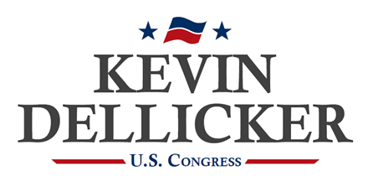
FOR IMMEDIATE RELEASE
April 15, 2024
Contact: Samuel Chen
schen@theliddellgroup.com
484-891-0345

LEHIGHTON 9/12 PROJECT ENDORSES
KEVIN DELLICKER FOR CONGRESS

LEHIGTON, PA – The Lehighton 9/12 Project endorsed Kevin Dellicker as the next congressman from Pennsylvania’s 7th District.

In an endorsement letter, Nickolas Smith, President of the Lehighton 9/12 Project, called Dellicker “the most experienced and qualified person to take on the challenge and help fight for the American people.” He added that Dellicker is “not a career politician” and emphasized his “desire to work for us – the American people.”

Dellicker thanked the organization for their support: “I am grateful for the support of the Lehighton 9/12 Project and their members. While Susan Wild has continuously disparaged the communities across Carbon County, I will be proud to represent them in Washington.”

The Lehighton 9/12 Project is the largest conservative grassroots organization in Carbon County. The organization has hosted several candidate forums and hosted a candidate debate in February that was televised on BRC TV.

***

Kevin Dellicker is a candidate for Congress in Pennsylvania’s 7th Congressional District. He serves as a military intelligence officer in the Pennsylvania Air National Guard and has served four overseas deployments in support of the Global War on Terrorism.

Military information & references to military service by Kevin Dellicker & Members of Congress do not imply endorsement by the Department of Defense, Air Force, Army, Navy, or National Guard.

###

